ISWCIA20-0961

Source language: English / Written on: 11/09/2020

Document prepared by Niamh McGarry (SAORSERVICES)

**ISWC Allocation Service: Onboarding Document for Publishers (Separate Process)**

# Introduction

The purpose of this document is to summarise the onboarding process for Publishers to the ISWC Allocation Service (IAS).

The key objective of the service is rapid (same day/next day) ISWC assignment, and communication and usage of ISWC by users in the digital value chain.

The onboarding process in this document relates to the Separate Process, within which Publishers submit a standalone IAS JSON file or IAS Flat (txt) File to the service via their Societies.

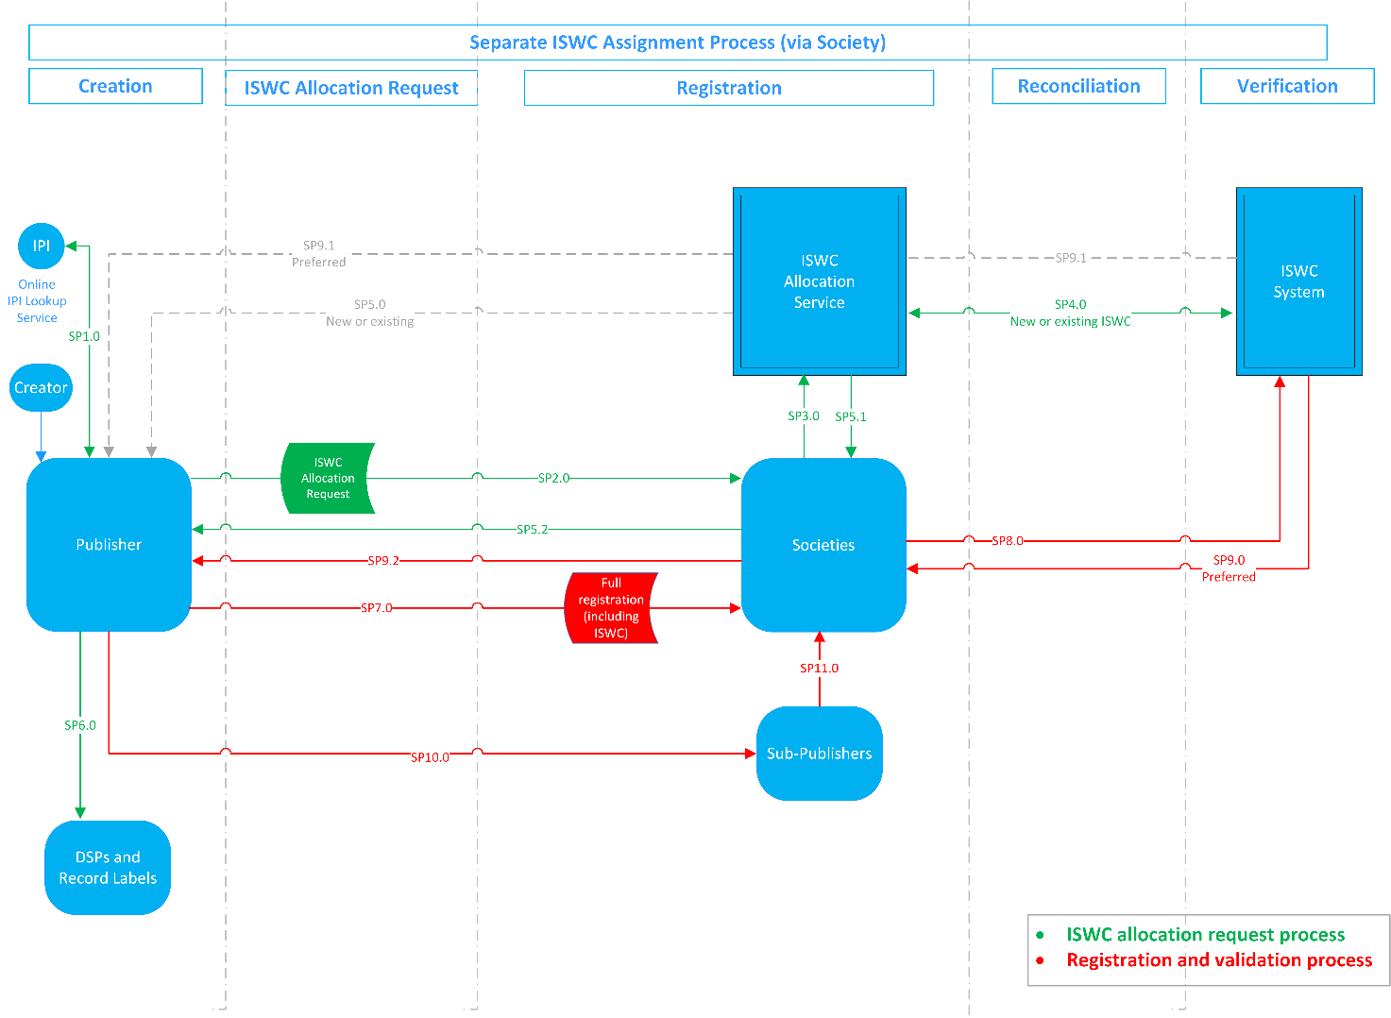

This document should be read in conjunction with the ISWC Allocation Service file format specification: [SPE_20200120_ISWC_AllocationAndResolutionSolution Release Version.](https://teams.microsoft.com/l/file/D044CECB-ED18-4695-9598-7433BE7BB2B5?tenantId=4197e6e7-fe92-417f-8cd8-0997d263db36&fileType=docx&objectUrl=https%3A%2F%2Fspanishpoint1.sharepoint.com%2Fsites%2FCISACSPISWC%2FShared%20Documents%2FAs%20Is%20System%2FRel%20-%20ISWC%20Allocation%20and%20Resolution%20Services%20WBS%204.3%2FSPE_20200120_ISWC_AllocationAndResolutionSolution%20Release%20Version_clean.docx&baseUrl=https%3A%2F%2Fspanishpoint1.sharepoint.com%2Fsites%2FCISACSPISWC&serviceName=teams&threadId=19:a78725c0b9b4485b86bc40ee740311b2@thread.skype&groupId=eefca450-9bf9-49ac-b171-01fb643f2cb3) Societies should pay specific attention to sections 2, 3 and 4 of this document when onboarding Publishers to the service. Section 5 provides a brief summary of subsequent processes which take place outside the ISWC Allocation Service, e.g. submission of the full work registration by the Publisher and amendments to ISWC metadata.

# Pre Conditions for Using the Service

Below are the pre-conditions for Publishers using the ISWC Allocation Service:

|  |  |
| --- | --- |
| Publisher has access to CIS-Net Rights Holders Access (RHA) Online IPI Look-up and MWI  *(so that they can source IPI numbers which are mandatory for ISWCs (even for non-controlled creators)* |  |
| Publisher has confirmed the CWR submitter code and IPI number which they will use for the service *(the IPI number must be linked to the submitter code and associated with the Society who is offering the service)* |  |
| Publisher has confirmed the file type it will generate for the service (JSON or Flat File). |  |

# Onboarding Checklist for Societies

### Publisher UAT

|  |  |
| --- | --- |
| Spanish Point has created an IAS folder for the Publisher in the UAT environment  (Society should request creation of this folder via [iswc.support@cisac.org](mailto:iswc.support@cisac.org)). |  |
| Society can transfer files in the UAT environment from its IAS folder to the Spanish Point IAS folder (the Publisher will drop files into the Society’s folder which then need to transfer to the Spanish Point folder where they will be picked up by the IAS). |  |
| Society has provided the Publisher with their UAT folder location and credentials for uploading files and retrieving ACKs. |  |
| Society has informed the Publisher that ISWCs returned during UAT are not genuine ISWCs and should not be disseminated |  |
| Publisher uploads test file to the UAT folder - which is accepted and processed by the service |  |
| Publisher successfully retrieves the ACK file for its submission |  |

### Publisher Go Live

|  |  |
| --- | --- |
| Spanish Point has created an IAS folder for the Publisher in the Production environment (Society should request creation of this folder via [iswc.support@cisac.org](mailto:iswc.support@cisac.org)) |  |
| Society can transfer files in the Production environment from its IAS folder to the Spanish Point IAS folder (the Publisher will drop files into the Society’s folder which then need to transfer to the Spanish Point folder where they will be picked up by the IAS). |  |
| Society has provided the Publisher with their Production folder location and credentials for uploading files and retrieving ACKs. |  |
| Publisher uploads its first file to the Production folder - which is accepted and processed by the service |  |
| Publisher successfully retrieves the ACK file for its submission |  |

# Onboarding Phases

## Publisher UAT

*Process Points: SP1.0, SP2.0, SP3.0, SP4.0, SP5.1, SP5.2*

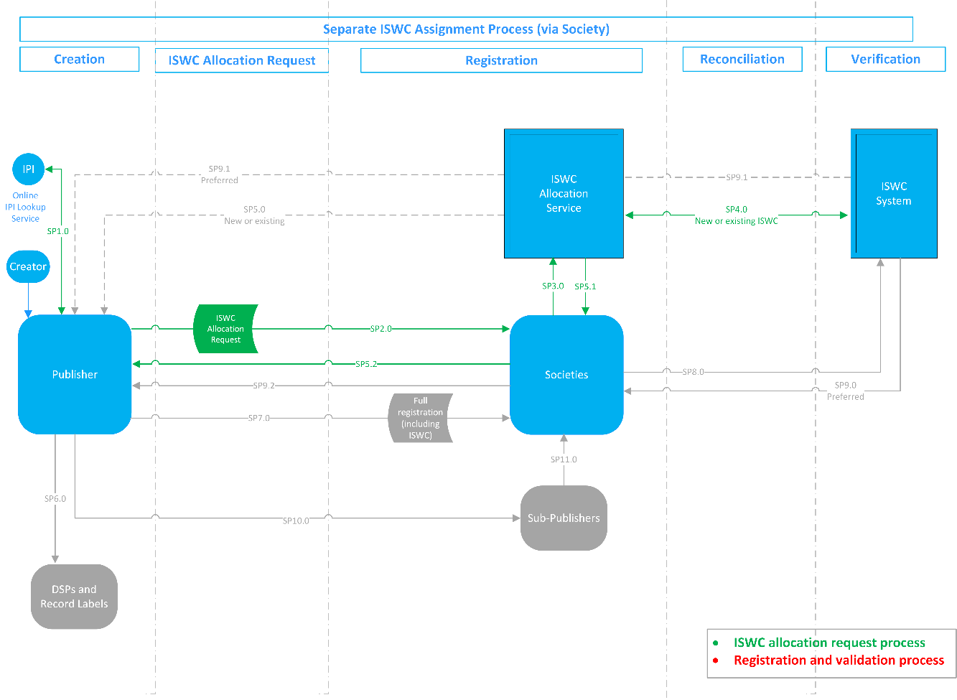

Prior to onboarding to the service, the Publisher must submit a test file to the UAT environment of the service via their Society.

Test files should contain a maximum of 20 works. It is recommended that Publishers include invalid works which will not be assigned an ISWC by the service so that error messages will be returned to the Publisher. This will help ensure Publishers can interpret the error code generated by the services. A list of error codes which may be generated by the ISWC Allocation Service are contained within the Appendix of this document. Invalid works include works which:

* contain a missing Submitter IPI Number
* contain an invalid Writer Designation Code (role)
* omit a Writer IPI Name Number
* contain an invalid Writer IPI Number
* contain no Writer metadata at all
* omit a Work Title

An ACK will be returned by the service. The Publisher should be able to retrieve this ACK and understand the error messages.

**Important**: **ISWCs returned during UAT are not genuine ISWCs and should not be disseminated by the Society or Publisher.**

**Phase Validation:**

|  |  |  |
| --- | --- | --- |
|  | Validation Point | Completion date for UAT |
| 4.1.1 | Publisher submits a file to the ISWC Allocation Service UAT environment and successfully completes the UAT phase. |  |

## Publisher Go Live

Following successful completion of UAT, the Society should provide the Publisher with the location and credentials for uploading files to the Production environment and retrieving ACKs.

## Publisher Submission of 1st File to Production Environment

The first file which the Publisher submits to the Production environment should contain maximum 20 works. Publishers should review and ingest the ACK for the first file submission before submitting further files to the service.

## Publisher Dissemination of ISWC

*Process Points: SP6.0, SP10.0, SP11.0*

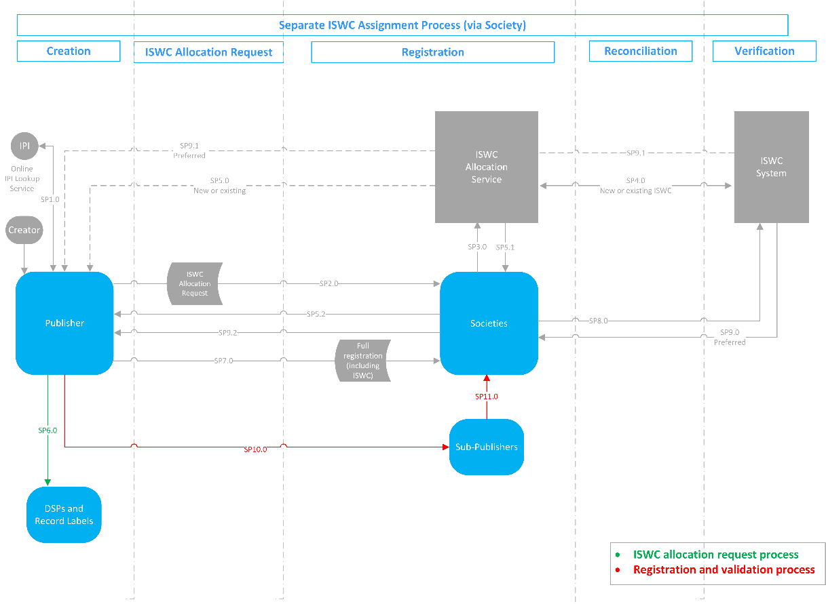

The Publisher disseminates the ISWC to sub-Publishers and DSPs.

**Business Rules for Publishers:**

The Publisher disseminates the work(s) information, with ISWC number and IPI information, to sub-Publishers and DSPs.

**Phase Validation:**

|  |  |  |
| --- | --- | --- |
|  | Validation Point | Completed? |
| 4.4.1 | Publisher confirms dissemination of ISWCs and IPI information to sub-Publishers and DSPs, e.g. via proprietary file or centralised system |  |

# Subsequent Phases (outside the ISWC Allocation Service)

The following activities are not processed through the ISWC Allocation Service. They are part of the usual Publisher to Society work notification process. The ACK returned to the Publisher is a Society ACK; it is not generated by the IAS. If the work which was originally assigned an ISWC by the IAS is given a new preferred ISWC by the ISWC Database, this will be returned to the Publisher in the regular Society ACK.

## Submission of Work Registration (without change to metadata)

*Process Points: SP7.0, SP8.0, SP9.0, SP9.2*

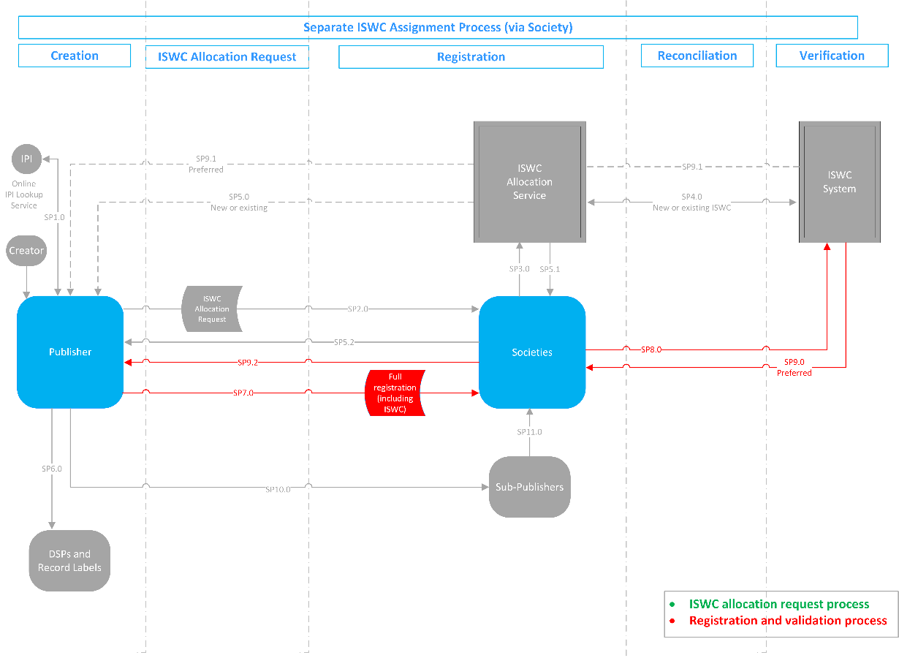

Following allocation of an ISWC from the service, the Publisher submits the full work registration to the Society in the usual manner. This registration contains **no changes** to the title or IP metadata originally submitted in the IAS file.

**Business Rules for Publishers:**

1. The Publisher submits a full registration to the Society which contains the ISWC allocated by the service.
2. Upon return of the Society ACK file, the Publisher should ensure they have the correct **preferred** ISWC in their proprietary works database.
3. The Publisher should disseminate the work information, with preferred ISWC number and IPI information, to sub-Publishers and DSPs.

**Business Rules for Societies:**

1. The Society sends the reconciled metadata from the registration, including the ISWC number, to the ISWC System for validation.
2. The Society sends an ACK, containing the **preferred** ISWC, to the submitting Publisher or makes the ACK available for the Publisher to retrieve.

## Submission of Work Registration (with changes to metadata)

*Process Points: SP7.0, SP8.0, SP9.0, SP9.2*

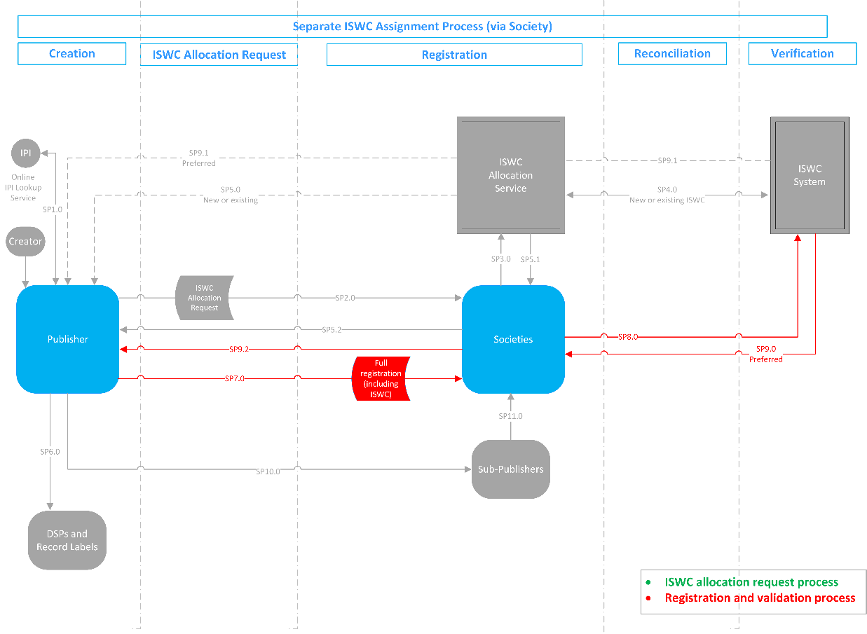

Following allocation of an ISWC from the service, the Publisher submits a full registration to the Society in the usual manner. This registration contains **changes** to the title or IP metadata submitted in the original IAS file.

**Business Rules for Publishers:**

1. The Publisher submits a full registration to the Society which contains the ISWC allocated by the service.
2. Upon return of the Society ACK, the Publisher should ensure they have the correct **preferred** ISWC in their proprietary works database.
3. The Publisher should disseminate the updated work information, with preferred ISWC number and IPI information, to sub-Publishers and DSPs.

**Business Rules for Societies:**

1. The Society sends the reconciled metadata from the registration, including the ISWC number, to the ISWC System for validation.
2. The Society sends an ACK, containing the **preferred** ISWC, to the submitting Publisher or makes the ACK available for the Publisher to retrieve.

## Amended Registrations

Amendments to works are not processed by the ISWC Allocation Service. They are processed by the Society in its usual manner. If the work which was originally assigned an ISWC by the IAS is given a new preferred ISWC by the ISWC Database, this will be returned to the Publisher in the regular Society ACK.

**Business Rules for Publishers:**

1. The Publisher submits the updated registration to the Society which includes the ISWC.
2. Upon return of the Society ACK, the Publisher updates their proprietary works data to ensure they capture the correct **preferred** ISWC. (The **preferred** ISWC returned in the ACK may or may not match the existing ISWC which the Publisher has.)
3. The Publisher disseminates the updated work information, with preferred ISWC number and IPI information, to sub-Publishers and DSPs.

**Business Rules for Societies:**

1. The Society sends the updated metadata for the registration, including the ISWC number, to the ISWC System for validation.
2. The Society sends an ACK, containing the **preferred** ISWC, to the submitting Publisher or makes the ACK available for the Publisher to retrieve.

## Updates to ISWCs

In this scenario, the Society identifies multiple ISWCs for the same work and merges these works in their proprietary database. The changes are applied on the ISWC System. The Publisher is notified of the changes via the Society and updates their proprietary database.

**Business Rules for Societies:**

1. The Society notifies the ISWC System of the metadata (and associated ISWCs) to be updated/merged.
2. The Society sends an ACK, containing the preferred ISWC, to the submitting Publisher or makes the ACK available for the Publisher to retrieve.

**Business Rules for Publishers:**

1. Upon receipt of the Society ACK, the Publisher updates their proprietary works data to ensure they capture the updated work and ISWC information.
2. The Publisher disseminates the updated work and ISWC information to sub-Publishers and DSPs.

# Support

For creation of IAS folders for Publishers in the UAT and Production environments, Societies should log a request through [iswc.support@cisac.org](mailto:iswc.support@cisac.org).

For initial onboarding of Publishers, Societies can contact SaorServices for support – [niamh.mcgarry@saorservices.com](mailto:niamh.mcgarry@saorservices.com).

# Appendix

## Error Codes

The full list of error codes is available in the API specification. A list of error codes which may be generated by the ISWC Allocation Service are listed below.

|  |  |
| --- | --- |
| Error Code | Message |
| 100 | Generic Error |
| 102 | I.P. Name Number is required |
| 103 | Source Society Code is invalid |
| 104 | At least one I.P. is required on a submission |
| 105 | ISWC System Unable to process record, please resubmit |
| 106 | I.P. Role Code is required |
| 109 | Work Titles are required |
| 110 | Only one Original Title allowed |
| 111 | At least one creator I.P. is required |
| 118 | At least one Derived From DF record is required for a Derived Work of type "Modified Version" |
| 119 | The ISWC provided in the Derived From DF record is not a valid Preferred ISWC in the ISWC Database |
| 120 | Each Derived From DF record must contain either an ISWC or a Title |
| 121 | At least one Derived From DF record is required for a Derived Work of type "Composite" |
| 122 | Invalid Disambiguation ISWC |
| 123 | Invalid disambiguation reason code |
| 124 | One or more Disambiguation ISWCs must be provided |
| 125 | BLTVR must be blank or contain the letters B, L, T, V or R |
| 126 | Performer information must contain a Second Name or a Second Name and a First Name |
| 128 | One or more specified Disambiguation ISWCs are not Preferred ISWCs in the ISWC Database |
| 129 | Invalid Disambiguation ISWC |
| 134 | I.P. Name Number is invalid, must be numeric |
| 136 | Society Work Code is required |
| 137 | IP Name Number must be status 1 or 2 and exist in the IPI database |
| 139 | I.P. Role Code is invalid |
| 140 | The submitted transaction is not ISWC eligible and either no matching Preferred ISWC or multiple matches have been found through the matching rules as per MAT/04 |
| 142 | No specific error number - the whole file is rejected |
| 146 | Instrumentation Code is invalid |
| 147 | At least one Derived From DF record is required for a Derived Work of type "Excerpt" |
| 148 | I.P. is not accepted |
| 201 | DerivedFrom ISWCs do not match exactly one matching preferred ISWC |